 | الجمهورية العربية السورية  وزارة التعليم العالي والبحث العلمي  الجامعة السورية الخاصة | 

Smart Opinion Survey Platform
(Appendices and References)
Junior Project Report

Prepared by:
Yaman Bassam Almatar
Yousef Ahmad Alzoubi
Hasan Abdalruhman Yahya
Supervised by:
Eng. Shadi Blidi
Eng. Maya Alahmad

Project Repository:
https://github.com/Yaman8almatar/smart-survey-platform

Academic Year
2025 – 2026
Table of Contents

Table of Contents 2
List of Figures 3
List of Tables 5
Section Six: Appendices and References 6
Appendix A: Requirements Collection Materials 6
Appendix B: Detailed Design 11
Appendix B.1: Class Diagrams 11
Appendix B.2: ERD and Relational Schema 13
Appendix B.3: Component and Layered Architecture Diagrams 15
Appendix B.4: Modules Design 17
Appendix B.5: External API Design 17
Appendix B.6: Behavioral Diagrams 18
Appendix B.7: Smart Algorithm Design 24
Appendix B.8: UX Design, Mockups, Wireframes, and Final Screenshots 25
Appendix C: Detailed Testing Results 29
Appendix D: User Manual 30
D.1 Installation Requirements 30
D.2 Setup Commands 30
D.3 Running Tests 31
D.4 Service Provider Workflow 31
D.5 Respondent Workflow 31
D.6 Administrator Workflow 31
D.7 Troubleshooting 32
References 32

List of Figures
Figure | Title
Figure B.1 | Domain Class Diagram for the Smart Survey Platform
Figure B.2 | Application Layer Class Diagram for Services, Repositories, and Infrastructure
Figure B.3 | Chen Entity Relationship Diagram
Figure B.4 | Relational Schema Diagram
Figure B.5 | System Block Diagram
Figure B.6 | Layered System Architecture Design
Figure B.7 | Sequence Diagram - Publish Survey
Figure B.8 | Sequence Diagram - Submit Survey Response
Figure B.9 | Sequence Diagram - Generate System Reports
Figure B.10 | Activity Diagram - Service Provider Survey Workflow
Figure B.11 | Activity Diagram - Respondent Participation Workflow
Figure B.12 | Activity Diagram - Administrator Management and Reporting Workflow
Figure B.13 | DFD Level 0 for the Smart Survey Platform
Figure B.14 | State Machine Diagram for Survey Lifecycle
Figure B.15 | Public Home Page
Figure B.16 | Service Provider Dashboard
Figure B.17 | Survey Edit Page
Figure B.18 | Eligible Surveys Page
Figure B.19 | Survey Submission Confirmation Page
Figure B.20 | Analytics Dashboard
Figure B.21 | System Reports Page
Figure C.1 | Local Pytest Execution Result
Figure C.2 | GitHub Actions CI Successful Run

List of Tables
Table | Title
Table A.1 | Blank Requirements Collection Form
Table A.2 | Functional Requirements
Table A.3 | Non-Functional Requirements
Table A.4 | Use Case Inventory
Table A.5 | Requirements Traceability Matrix
Table B.1 | Detailed Module Design
Table B.2 | External API Design
Table B.3 | AI-Assisted Sentiment Analysis Flow
Table C.1 | Main Test Case Results
Table C.2 | Error Logs and Fixes
Table D.1 | Installation Requirements
Table D.2 | Service Provider Workflow
Table D.3 | Respondent Workflow
Table D.4 | Administrator Workflow
Table D.5 | Troubleshooting Guide

Section Six: Appendices and References
The appendices provide supporting materials for requirements, detailed design, testing evidence, user guidance, and references. They contain supporting artifacts that are too detailed to include in the main report body.

Appendix A: Requirements Collection Materials
Formal stakeholder survey results were not collected during the current project scope. Therefore, this appendix provides a blank requirements collection form and the final requirements artifacts used in the project documentation.
Table A.1: Blank Requirements Collection Form
Field | Description / Response
Stakeholder Name
Stakeholder Role | Service Provider / Respondent / Administrator / Other
Main Problem
Required Feature
Priority | High / Medium / Low
Acceptance Criteria
Notes

Table A.2: Functional Requirements
ID | Functional Requirement | Actor
FR-01 | The system shall allow a service provider to create an account using name, email, and password. | Service Provider
FR-02 | The system shall allow a respondent to create an account with demographic data. | Respondent
FR-03 | The system shall allow users to log in using email and password. | Service Provider, Respondent, System Administrator
FR-04 | The system shall allow authenticated users to log out. | Service Provider, Respondent, Administrator
FR-05 | The system shall allow service providers to create surveys with title and description. | Service Provider
FR-06 | The system shall allow service providers to update their own draft survey details. | Service Provider
FR-07 | The system shall allow service providers to delete their own draft surveys. | Service Provider
FR-08 | The system shall support multiple-choice, rating-scale, and open-text question types. | Service Provider, Respondent
FR-09 | The system shall allow service providers to add questions to their own draft surveys. | Service Provider
FR-10 | The system shall support updating and deleting questions on owned draft surveys. | Service Provider
FR-11 | The system shall allow service providers to define demographic targeting criteria for their own draft surveys. | Service Provider
FR-12 | The system shall allow service providers to publish surveys only when required publication conditions are satisfied. | Service Provider
FR-13 | The system shall allow service providers to close published surveys. | Service Provider
FR-14 | The system shall allow service providers to view analytics for their own surveys. | Service Provider
FR-15 | The system shall allow respondents to manage their demographic profile. | Respondent
FR-16 | The system shall list only eligible published surveys for a respondent. | Respondent
FR-17 | The system shall allow respondents to submit responses to eligible published surveys. | Respondent
FR-18 | The system shall prevent a respondent from submitting more than one response to the same survey. | Respondent
FR-19 | The system shall allow respondents to view surveys they have already answered. | Respondent
FR-20 | The system shall allow administrators to activate, suspend, and soft-delete user accounts. | System Administrator
FR-21 | The system shall allow administrators to generate system reports for platform activity. | System Administrator
FR-22 | The system shall run sentiment analysis for open-text answers and store the result state. | System
Table A.3: Non-Functional Requirements
NFR ID | Category | Requirement | Measurable Criterion / Verification
NFR-01 | Security | The system shall protect account passwords using Django password hashing. | Passwords are stored hashed, not plaintext.
NFR-02 | Security | The system shall restrict protected functions according to user roles. | Service Provider, Respondent, and Administrator workflows are separated by role checks.
NFR-03 | Security | The system shall load real runtime secrets and API tokens from environment variables. | Database settings and AI API token are loaded from environment variables; .env is not committed.
NFR-04 | Usability | The system shall provide role-specific navigation and dashboard pages. | Each role has relevant navigation links and dashboard pages.
NFR-05 | Usability | The system shall provide clear forms and feedback messages for main workflows. | Forms validate user input and display success or error messages.
NFR-06 | Performance | The system should return normal local page requests within 2 seconds during academic testing. | Target to be verified manually or with browser timing before final submission.
NFR-07 | Reliability | The system shall keep a submitted response saved if sentiment analysis fails. | Failed external analysis is recorded as FAILED without deleting the submitted response.
NFR-08 | Maintainability | The system shall separate UI, services, repositories, models, and external integrations. | The implementation follows Views → Services → Repositories → Models/ORM → Database.
NFR-09 | Data Integrity | The system shall prevent duplicate responses for the same survey and respondent. | One response per survey/respondent is enforced by validation and a database constraint.
NFR-10 | Privacy | The system shall store respondent demographic data on the server side for profile and survey eligibility workflows. | Demographic data is used for profile management and eligibility matching only.

Table A.4: Use Case Inventory
Use Case ID | Use Case Name | Primary Actor | Brief Description | Related Functional Requirement(s) | Priority
UC-01 | Register as Service Provider | Service Provider | Create a provider account using name, email, and password. | FR-01 | High
UC-02 | Register as Respondent | Respondent | Create a respondent account and initial demographic profile. | FR-02 | High
UC-03 | Login | Service Provider, Respondent, System Administrator | Authenticate with email and password and enter the correct role dashboard. | FR-03 | High
UC-04 | Logout | Service Provider, Respondent, System Administrator | End the authenticated session. | FR-04 | High
UC-05 | Create Survey | Service Provider | Create a draft survey with title and description. | FR-05 | High
UC-06 | Update Survey Details | Service Provider | Update title and description for an owned draft survey. | FR-06 | High
UC-07 | Delete Survey | Service Provider | Delete an owned draft survey. | FR-07 | Medium
UC-08 | Add Question | Service Provider | Add supported question types and options to an owned draft survey. | FR-08, FR-09 | High
UC-09 | Edit or Delete Question | Service Provider | Update or delete questions on owned draft surveys. | FR-10 | Medium
UC-10 | Define Targeting Criteria | Service Provider | Define optional gender, age, and region criteria for a survey. | FR-11 | High
UC-11 | Publish Survey | Service Provider | Publish a valid draft survey so eligible respondents can answer it. | FR-12 | High
UC-12 | Close Survey | Service Provider | Close a published survey so it no longer accepts responses. | FR-13 | Medium
UC-13 | View Analysis Results | Service Provider | View response counts, sentiment metrics, and question summaries for an owned survey. | FR-14, FR-22 | High
UC-14 | Manage Demographic Profile | Respondent | View or update age, gender, region, and interests. | FR-15 | High
UC-15 | View Eligible Surveys | Respondent | View published surveys matching profile criteria that the respondent has not answered. | FR-16 | High
UC-16 | Submit Survey Response | Respondent | Submit answers to an eligible published survey. | FR-17, FR-18, FR-22 | High
UC-17 | View Answered Surveys | Respondent | View surveys previously answered by the respondent. | FR-19 | Medium
UC-18 | Manage User Accounts | System Administrator | Activate, suspend, or soft-delete user accounts. | FR-20 | High
UC-19 | Generate System Reports | System Administrator | Generate user, survey, response, activity, and most-active-survey metrics. | FR-21 | High

Table A.5: Requirements Traceability Matrix
Req. ID | Requirement Summary | Related Use Case | Design / Implementation Component | Related Test Case
FR-01 | Register service provider account. | UC-01 | AuthenticationService, UserRepository, User model, registration view/form | TC-01
FR-02 | Register respondent with demographic data. | UC-02 | AuthenticationService, ProfileRepository, User model, RespondentProfile model | TC-02
FR-03 | Login using email and password. | UC-03 | AuthenticationService, UserRepository, Django authentication/session | TC-03
FR-04 | Logout authenticated users. | UC-04 | Django logout view and session framework | TC-04
FR-05 | Create surveys with title and description. | UC-05 | SurveyService, SurveyRepository, Survey model, survey form/view | TC-05
FR-06 | Update own draft survey details. | UC-06 | SurveyService, SurveyRepository, Survey model | TC-05
FR-07 | Delete own draft surveys. | UC-07 | SurveyService, SurveyRepository, Survey model | TC-05
FR-08 | Support multiple-choice, rating-scale, and open-text question types. | UC-08, UC-16 | Question model, Answer model, QuestionService, ResponseService | TC-06
FR-09 | Add questions to owned draft surveys. | UC-08 | QuestionService, QuestionRepository, QuestionOption model, question form/view | TC-06
FR-10 | Update and delete questions on owned draft surveys. | UC-09 | QuestionService, QuestionRepository | TC-07
FR-11 | Define demographic targeting criteria. | UC-10 | TargetingService, TargetingRepository, TargetingCriteria model | TC-08
FR-12 | Publish surveys only when publication conditions are satisfied. | UC-11 | SurveyService, QuestionRepository, TargetingRepository, Survey model | TC-09
FR-13 | Close published surveys. | UC-12 | SurveyService, SurveyRepository, Survey model | TC-09
FR-14 | View analytics for owned surveys. | UC-13 | AnalysisService, ResponseRepository, AnalysisRepository, analytics dashboard | TC-10
FR-15 | Manage respondent demographic profile. | UC-14 | ProfileService, ProfileRepository, RespondentProfile model, profile form/view | TC-11
FR-16 | List only eligible published surveys for respondent. | UC-15 | SurveyService, TargetingRepository, ResponseRepository, ProfileRepository | TC-12
FR-17 | Submit responses to eligible published surveys. | UC-16 | ResponseService, QuestionService, Response model, Answer model | TC-13
FR-18 | Prevent duplicate response for same survey/respondent. | UC-16 | ResponseService, ResponseRepository, Response unique constraint | TC-13
FR-19 | View already answered surveys. | UC-17 | ResponseService, ResponseRepository, answered surveys view/template | TC-14
FR-20 | Activate, suspend, and soft-delete user accounts. | UC-18 | AdminService, UserRepository, User model, admin user management view | TC-15
FR-21 | Generate system reports for platform activity. | UC-19 | AdminService, UserRepository, SurveyRepository, ResponseRepository, reports dashboard | TC-16
FR-22 | Run sentiment analysis for open-text answers and store result state. | UC-16, UC-13 | AnalysisService, HuggingFaceClient, AnalysisRepository, SentimentAnalysisResult model | TC-17

Appendix B: Detailed Design
This appendix includes detailed design artifacts including class diagrams, ERD, component architecture, modules design, API design, behavioral diagrams, smart algorithm design, and user interface screenshots.

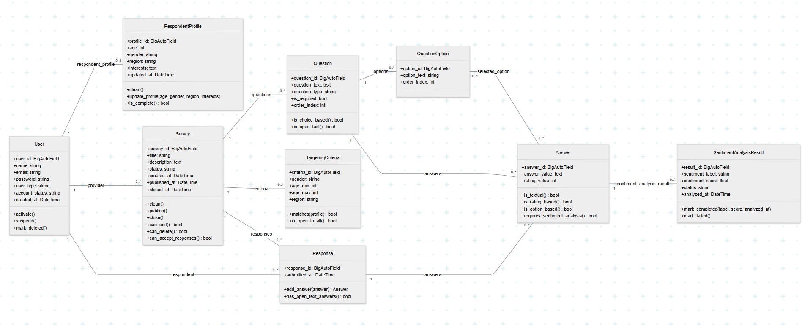
Appendix B.1: Class Diagrams

Figure B.1: Domain Class Diagram for the Smart Survey Platform
The domain class diagram shows the main persistent entities and their relationships.


Figure B.2: Application Layer Class Diagram for Services, Repositories, and Infrastructure
The application layer class diagram separates services, repositories, and infrastructure from the domain model to improve readability.

Appendix B.2: ERD and Relational Schema
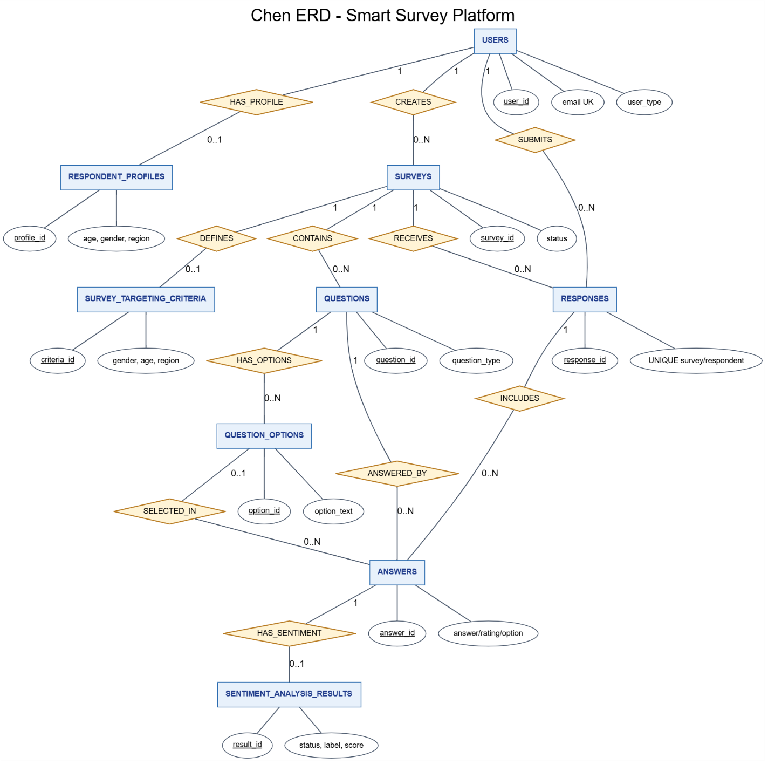
Figure B.3: Chen Entity Relationship Diagram

Figure B.4: Relational Schema Diagram

Appendix B.3: Component and Layered Architecture Diagrams
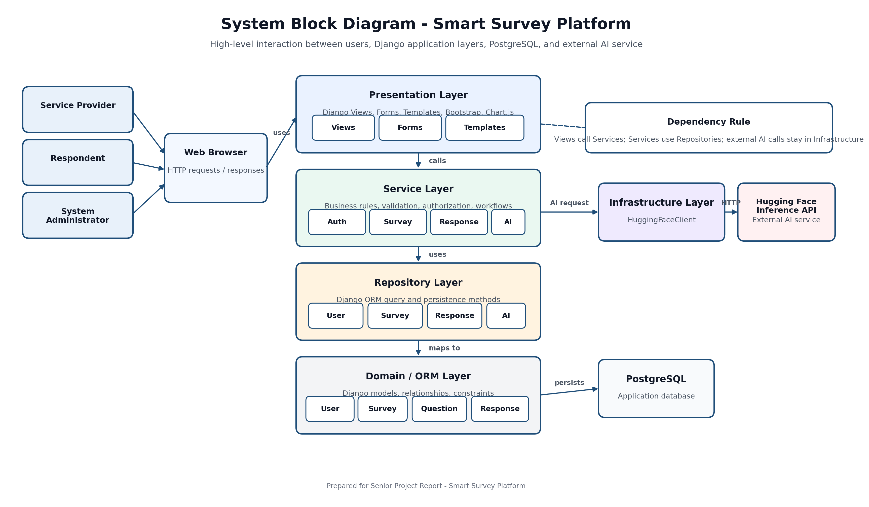
Figure B.5: System Block Diagram
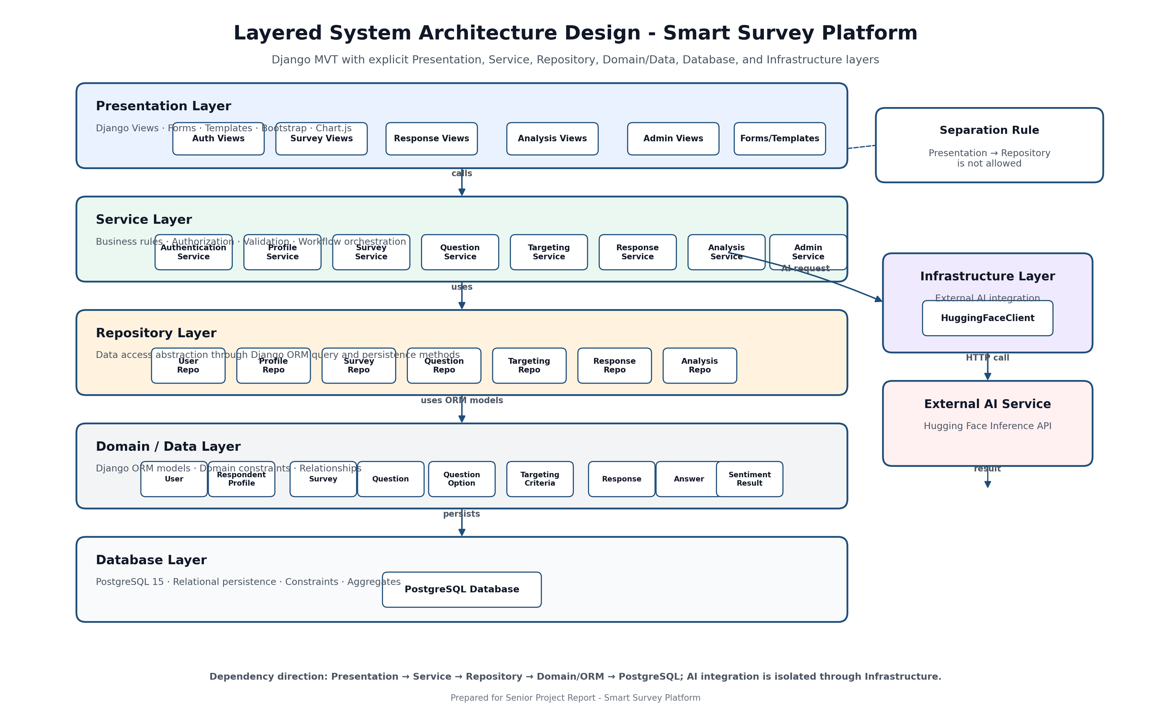
Figure B.6: Layered System Architecture Design

Appendix B.4: Modules Design
Table B.1: Detailed Module Design
Module | Main Files | Responsibility
Authentication and Users | apps/users/, services/authentication_service.py, repositories/user_repository.py | Registration, login, logout, email authentication, and role-based routing.
Survey Management | apps/surveys/, services/survey_service.py, repositories/survey_repository.py | Survey lifecycle management: create, update, delete, publish, close, and list surveys.
Question Management | services/question_service.py, repositories/question_repository.py | Add and validate question types, question options, ordering, and response-form question data.
Targeting Criteria | services/targeting_service.py, repositories/targeting_repository.py | Save demographic targeting and match respondents to eligible surveys.
Response Submission | services/response_service.py, repositories/response_repository.py | Validate eligibility, prevent duplicate responses, save responses and answers, and trigger analysis.
Analysis and Sentiment | services/analysis_service.py, infrastructure/huggingface_client.py | Analyze open-text answers and produce analytics summaries.
Administration | services/admin_service.py, apps/admin_panel/ | User account management and system report generation.
Core Domain Models | apps/core/models/, core/enums.py, core/exceptions.py | Entities, constraints, enumerations, and domain exceptions.

Appendix B.5: External API Design
Table B.2: External API Design
Field | Description
API Name | Hugging Face Inference API
API Type | External AI API
Purpose | Perform sentiment analysis on open-text survey answers.
Endpoint | HF_SENTIMENT_MODEL_URL environment variable.
Method | POST
Authentication | Bearer token configured through HF_API_TOKEN environment variable.
Request Body | { "inputs": text }
Return Value | Sentiment label and confidence score, normalized internally to POSITIVE, NEUTRAL, or NEGATIVE.
Error Cases | 401/403, 404, 429, 5xx, timeout, request failure, invalid JSON, invalid payload, unknown label, or invalid score.
Implementation Location | infrastructure/huggingface_client.py

Appendix B.6: Behavioral Diagrams
The following sequence and activity diagrams document the major behavioral flows selected for the appendix.
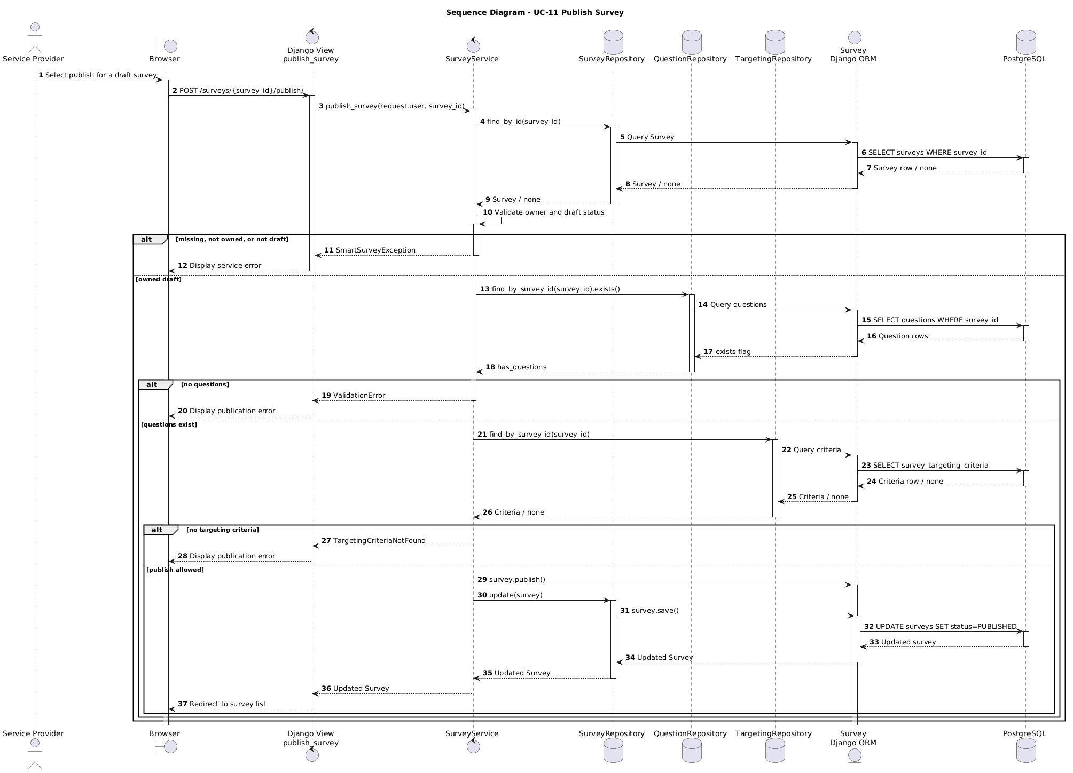
Figure B.7: Sequence Diagram - Publish Survey
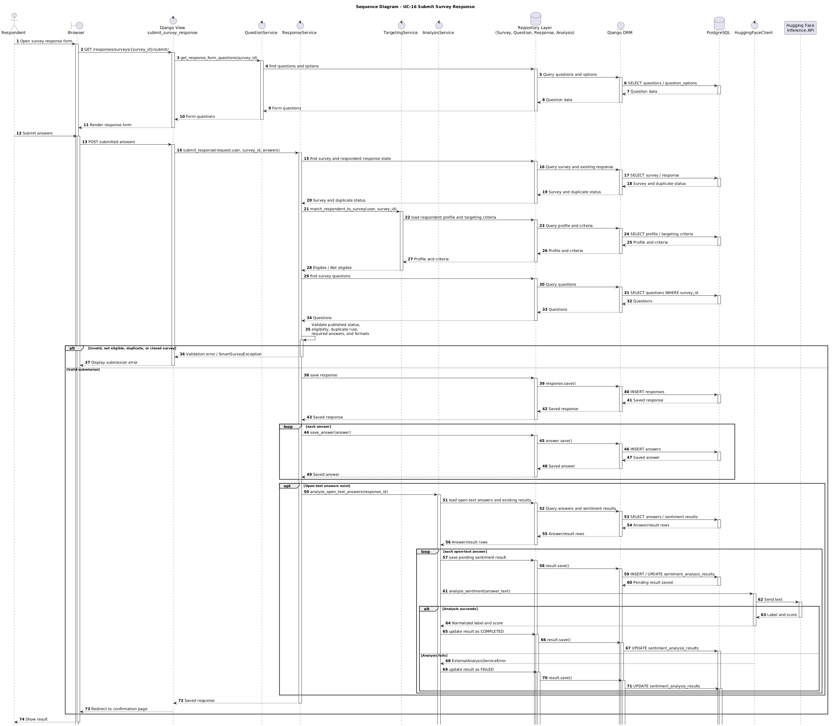
Figure B.8: Sequence Diagram - Submit Survey Response
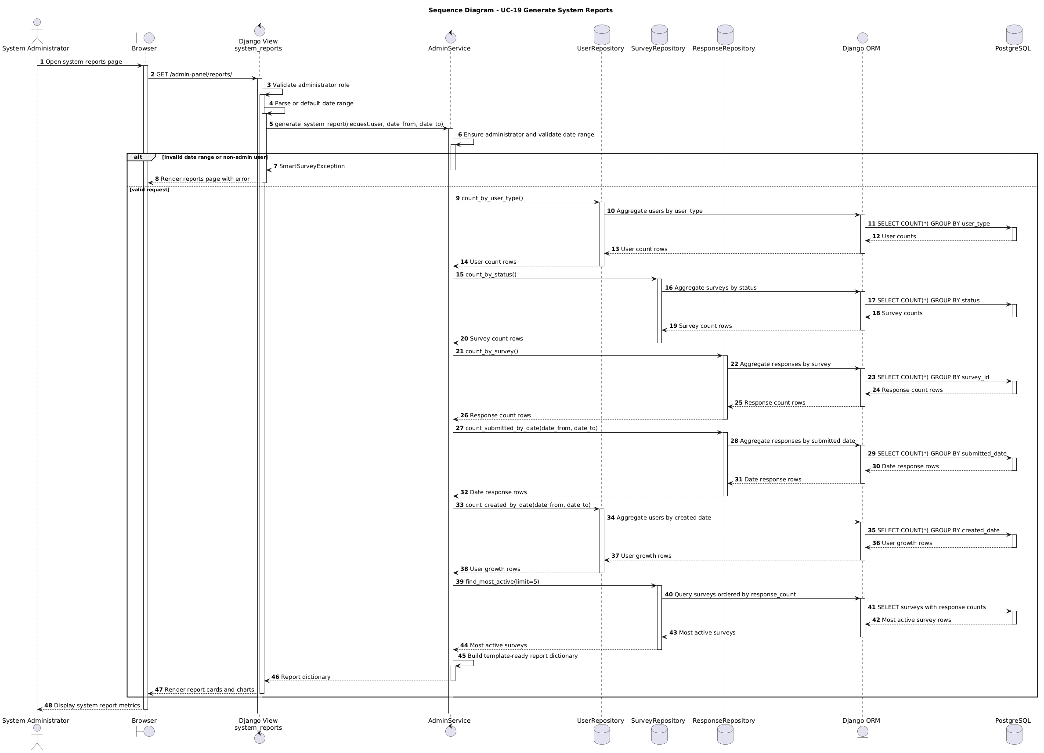
Figure B.9: Sequence Diagram - Generate System Reports
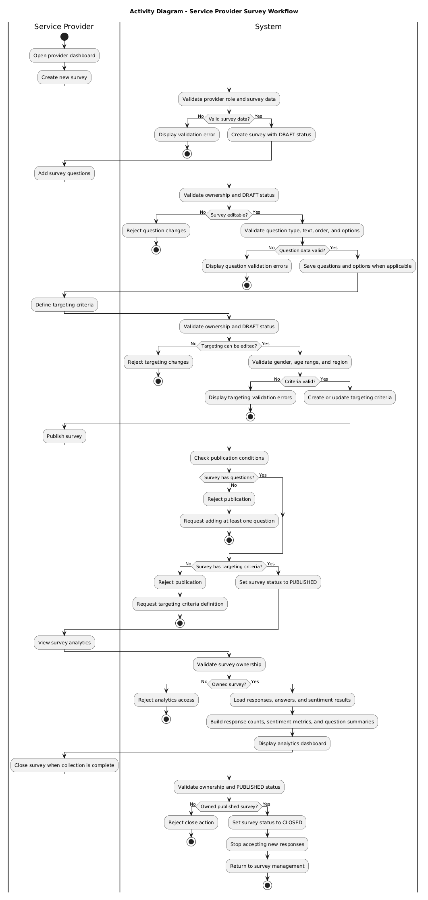
Figure B.10: Activity Diagram - Service Provider Survey Workflow
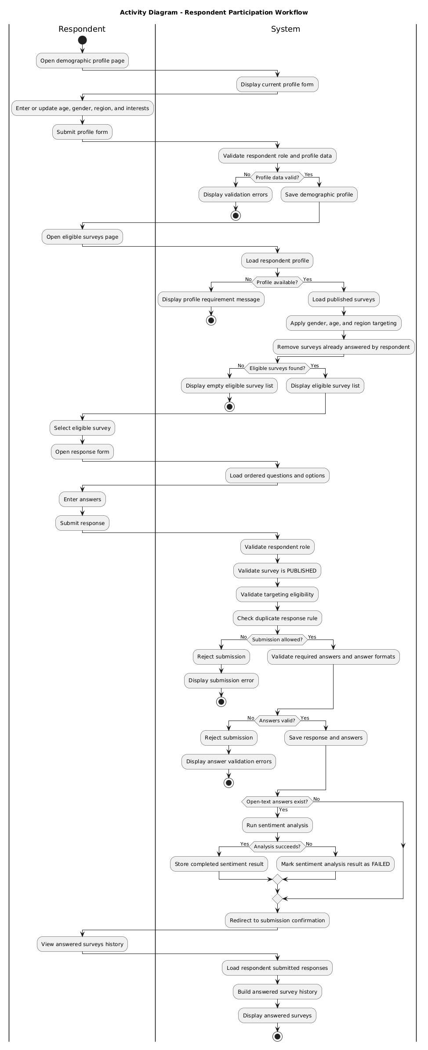
Figure B.11: Activity Diagram - Respondent Participation Workflow
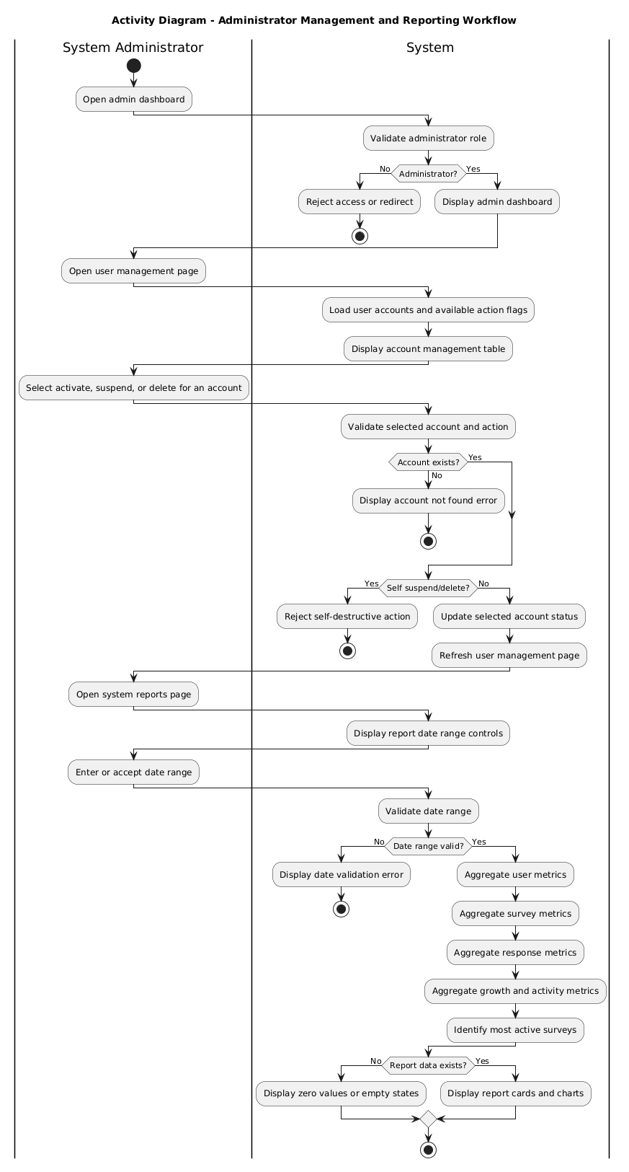
Figure B.12: Activity Diagram - Administrator Management and Reporting Workflow

Appendix B.7: Smart Algorithm Design
The system uses an external pretrained sentiment analysis model through the Hugging Face Inference API. The project does not train a new machine learning model from scratch.
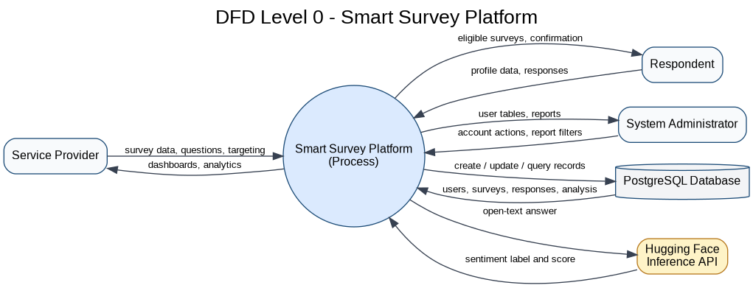
Figure B.13: DFD Level 0 for the Smart Survey Platform
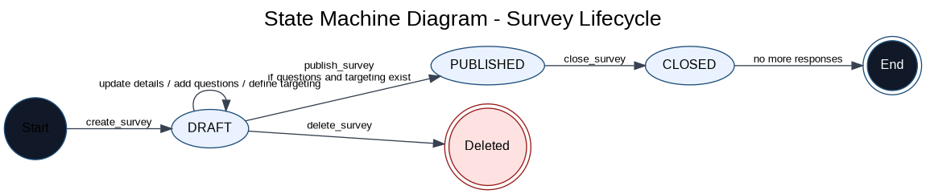
Figure B.14: State Machine Diagram for Survey Lifecycle
Table B.3: AI-Assisted Sentiment Analysis Flow
Step | Description | Output
1 | Detect open-text answers after response submission. | Open-text answers selected for analysis.
2 | Create or reset pending sentiment analysis result. | PENDING analysis record.
3 | Send text to HuggingFaceClient. | External API request.
4 | Normalize returned label and score. | Internal sentiment label and score.
5 | Store completed result. | COMPLETED result with label, score, and timestamp.
6 | Handle external failure. | FAILED result without deleting the submitted response.
Algorithm B.1: Sentiment Analysis Pseudocode
FOR each answer in submitted response:
IF answer requires sentiment analysis:
create or reset pending sentiment result
TRY:
send answer text to HuggingFaceClient
normalize returned label and score
mark result as COMPLETED
CATCH external analysis error:
mark result as FAILED
END FOR

Appendix B.8: UX Design, Mockups, Wireframes, and Final Screenshots
The following screenshots show the implemented final interface screens.
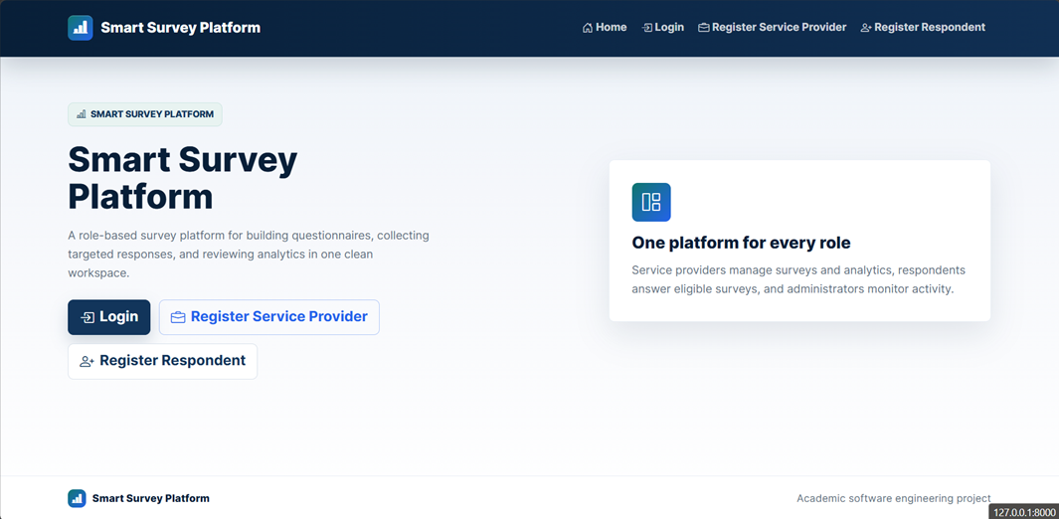
Figure B.15: Public Home Page
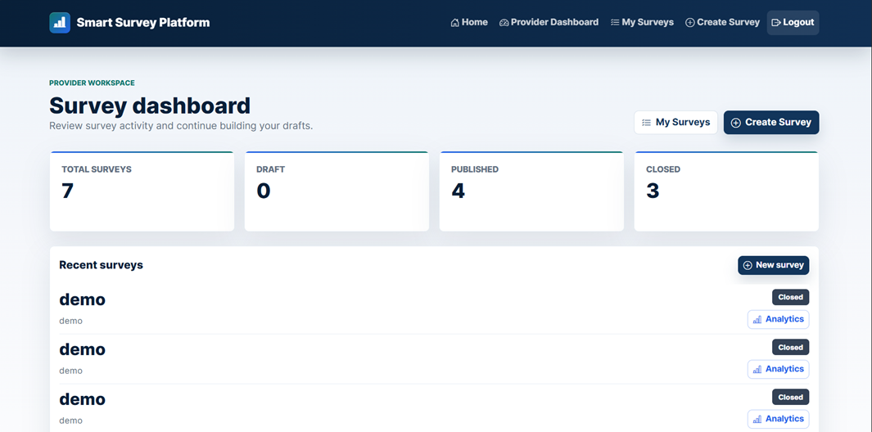
Figure B.16: Service Provider Dashboard
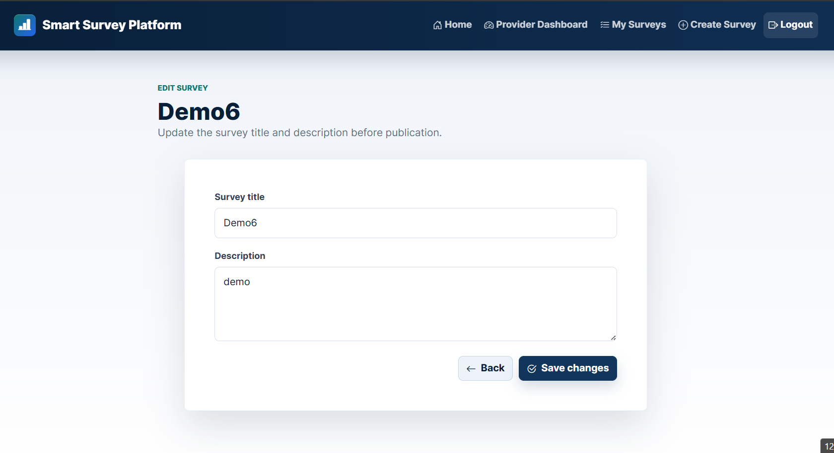
Figure B.17: Survey Edit Page
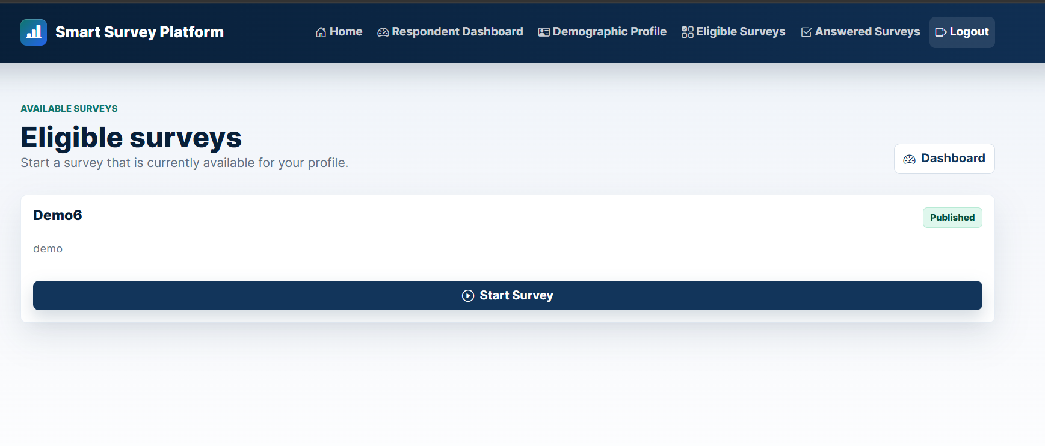
Figure B.18: Eligible Surveys Page
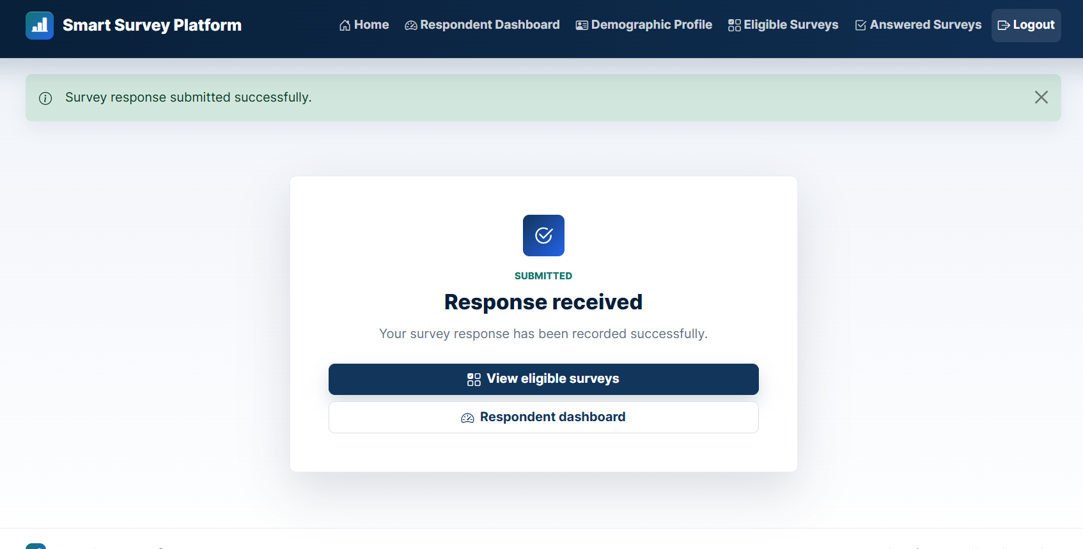
Figure B.19: Survey Submission Confirmation Page
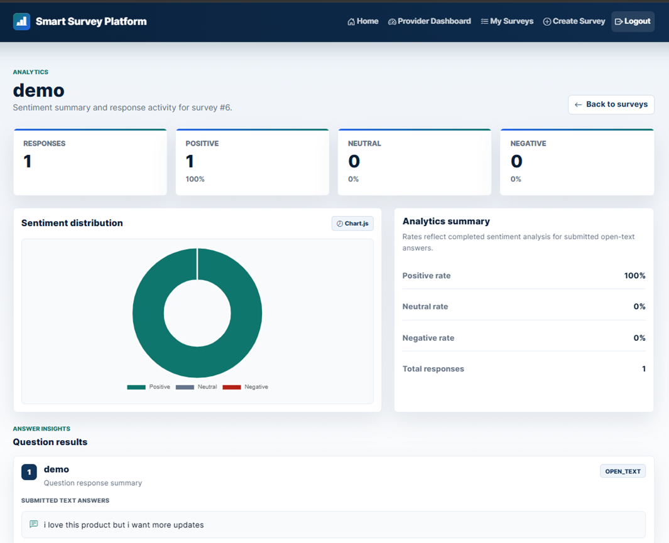
Figure B.20: Analytics Dashboard
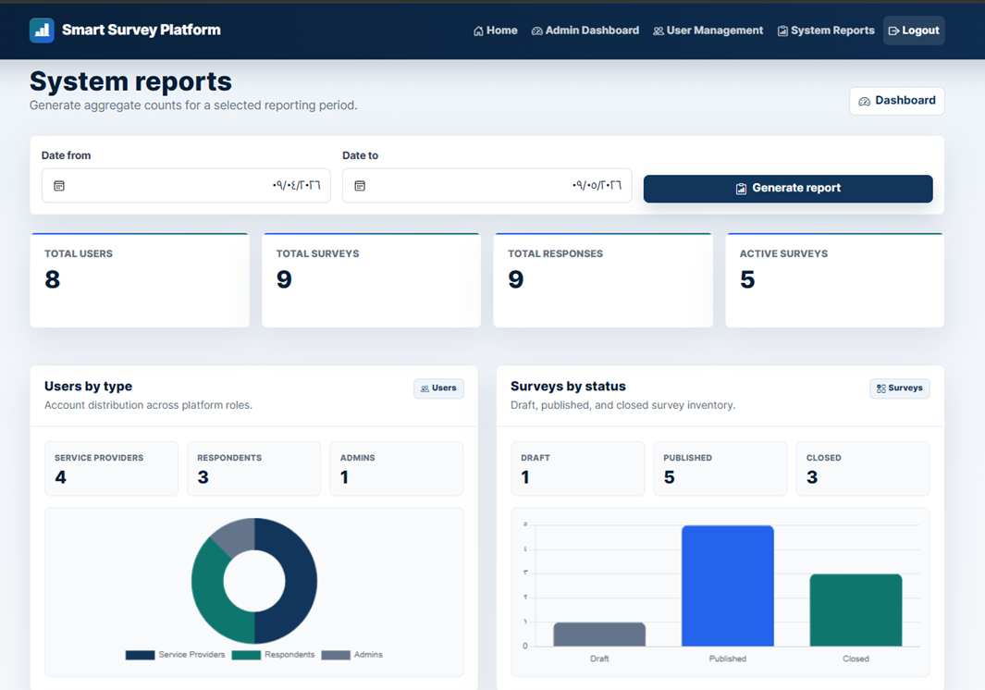
Figure B.21: System Reports Page

Appendix C: Detailed Testing Results
This appendix contains detailed automated testing and CI execution evidence.
Figure C.1: Local Pytest Execution Result
The service-layer automated test suite passed successfully with 163 passed tests and 0 failed tests in 84.74 seconds.
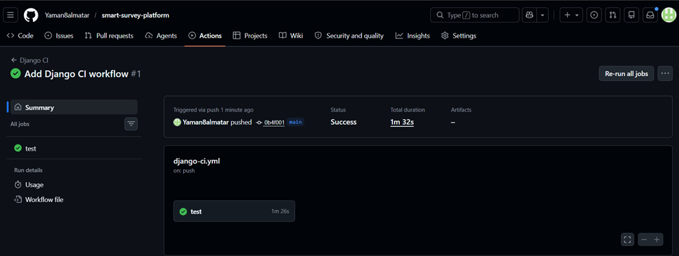
Figure C.2: GitHub Actions CI Successful Run
The GitHub Actions CI workflow completed successfully with status Success and total duration of 1 minute and 32 seconds.
Table C.1: Main Test Case Results
Test Case | Scenario | Expected Result | Status
TC-01 | Register service provider | Provider account created | Passed
TC-02 | Register respondent | Respondent account and profile created | Passed
TC-03 | Reject duplicate email | Validation error returned | Passed
TC-04 | Publish incomplete survey rejection | Validation error returned | Passed
TC-05 | Filter eligible surveys | Only matching unanswered published surveys shown | Passed
TC-06 | Reject duplicate response | Duplicate response error returned | Passed
TC-07 | Analyze open-text answer safely | Sentiment result created or failed safely | Passed
TC-08 | Admin suspends account | Account status becomes SUSPENDED | Passed
Table C.2: Error Logs and Fixes
Issue | Cause | Resolution
Python version mismatch | Local Python 3.7 was incompatible with Django 4.2. | Used the correct virtual environment and GitHub Actions Python 3.11.
External AI failure risk | Hugging Face API may fail because of network, token, or response issues. | The system stores the response first and marks analysis as FAILED when the external service fails.
Legacy diagram mismatch | Older diagrams did not match the current implementation. | The diagrams were audited and corrected against the current repository code.

Appendix D: User Manual
This appendix provides a concise installation, execution, testing, and usage guide for the Smart Survey Platform.

D.1 Installation Requirements
Table D.1: Installation Requirements
Requirement | Description
Python | Python 3.11 is recommended.
PostgreSQL | PostgreSQL 15 through Docker Compose.
Git | Required to clone and version-control the repository.
Browser | Required to access the server-rendered web application.
Hugging Face API Token | Required only for real external sentiment analysis execution. Dummy values can be used in tests.

D.2 Setup Commands
python -m venv .venv
.\.venv\Scripts\activate
pip install -r requirements.txt
docker compose up -d
python manage.py migrate
python manage.py runserver

D.3 Running Tests
python manage.py check
python -m pytest tests/services -q

D.4 Service Provider Workflow
Table D.2: Service Provider Workflow
Step | Action
1 | Register or log in as a service provider.
2 | Open the provider dashboard.
3 | Create or edit a survey.
4 | Add questions and options.
5 | Define targeting criteria.
6 | Publish the survey.
7 | View analytics after responses are submitted.

D.5 Respondent Workflow
Table D.3: Respondent Workflow
Step | Action
1 | Register or log in as a respondent.
2 | Complete or update the demographic profile.
3 | Open the eligible surveys page.
4 | Start an eligible survey.
5 | Submit survey answers.
6 | View answered surveys.

D.6 Administrator Workflow
Table D.4: Administrator Workflow
Step | Action
1 | Log in as system administrator.
2 | Open the admin dashboard.
3 | Manage user accounts.
4 | Generate system reports.

D.7 Troubleshooting
Table D.5: Troubleshooting Guide
Problem | Recommended Action
PostgreSQL connection fails | Check Docker Compose service, DB_HOST, DB_PORT, DB_NAME, DB_USER, and DB_PASSWORD.
Python command uses old version | Activate the correct virtual environment and use Python 3.11.
Hugging Face call fails | Check HF_API_TOKEN and HF_SENTIMENT_MODEL_URL or use test doubles for tests.
Tests fail due to environment | Run tests in the configured virtual environment or GitHub Actions CI.

References

[1] I. Sommerville, Software Engineering, 10th ed. Boston, MA, USA: Pearson, 2015.
[2] R. S. Pressman and B. R. Maxim, Software Engineering: A Practitioner’s Approach, 9th ed. New York, NY, USA: McGraw-Hill, 2019.
[3] AAPOR, Data Quality Metrics for Online Samples: Considerations for Study Design and Analysis, 2023. [Online]. Available: https://aapor.org/wp-content/uploads/2023/02/Task-Force-Report-FINAL.pdf. Accessed: May 9, 2026.
[4] M.-J. Wu, K. Zhao, and F. Fils-Aime, “Response rates of online surveys in published research: A meta-analysis,” Computers in Human Behavior Reports, vol. 7, p. 100206, Aug. 2022, doi: 10.1016/j.chbr.2022.100206.
[5] S. Jaeger, “Factors affecting data quality of online questionnaires: Issues and metrics for sensory and consumer research,” Food Quality and Preference, vol. 102, p. 104676, Dec. 2022, doi: 10.1016/j.foodqual.2022.104676.
[6] K. L. Tan, C. P. Lee, and K. M. Lim, “A survey of sentiment analysis: Approaches, datasets, and future research,” Applied Sciences, vol. 13, no. 7, p. 4550, 2023, doi: 10.3390/app13074550.
[7] A. Patel, P. Oza, and S. Agrawal, “Sentiment analysis of customer feedback and reviews for airline services using language representation model,” Procedia Computer Science, vol. 218, pp. 2459–2467, 2023, doi: 10.1016/j.procs.2023.01.221.
[8] H. A. Samir, L. Abd-Elmegid, and M. Marie, “Sentiment analysis model for airline customers’ feedback using deep learning techniques,” International Journal of Engineering Business Management, vol. 15, pp. 1–18, 2023, doi: 10.1177/18479790231206019.

[9] Qualtrics, “Online Panels,” Qualtrics Support. [Online]. Available: https://www.qualtrics.com/support/survey-platform/distributions-module/online-panels/. Accessed: May 9, 2026.
[10] SurveyMonkey, “How to reach a target audience,” SurveyMonkey Help Center. [Online]. Available: https://help.surveymonkey.com/en/surveymonkey/solutions/target-audience/. Accessed: May 9, 2026.
[11] Google, “View and manage form responses,” Google Docs Editors Help. [Online]. Available: https://support.google.com/docs/answer/139706. Accessed: May 9, 2026.
[12] Django Software Foundation, “Django documentation.” [Online]. Available: https://docs.djangoproject.com/. Accessed: May 9, 2026.
[13] PostgreSQL Global Development Group, “PostgreSQL 15 Documentation.” [Online]. Available: https://www.postgresql.org/docs/15/. Accessed: May 9, 2026.
[14] Hugging Face, “Text Classification - Inference Providers Documentation.” [Online]. Available: https://huggingface.co/docs/inference-providers/tasks/text-classification. Accessed: May 9, 2026.
[15] Bootstrap Team, “Bootstrap documentation.” [Online]. Available: https://getbootstrap.com/docs/5.0/getting-started/introduction/. Accessed: May 9, 2026.
[16] Chart.js Contributors, “Chart.js documentation.” [Online]. Available: https://www.chartjs.org/docs/latest/. Accessed: May 9, 2026.
[17] pytest-dev, “pytest documentation.” [Online]. Available: https://docs.pytest.org/. Accessed: May 9, 2026.
[18] Cardiff NLP, “twitter-roberta-base-sentiment-latest model card.” [Online]. Available: https://huggingface.co/cardiffnlp/twitter-roberta-base-sentiment-latest. Accessed: May 9, 2026.

